Website corrections points – V1
- Digital Nest Solution logo should be Large size and should come to corner left
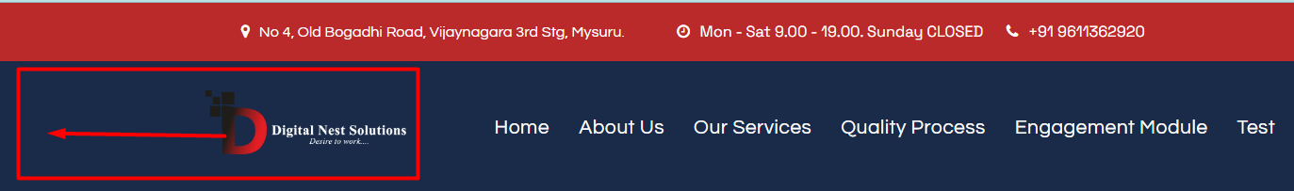
- Need to get the dropdown for all types of annotation after selecting data annotation and also same for Design services
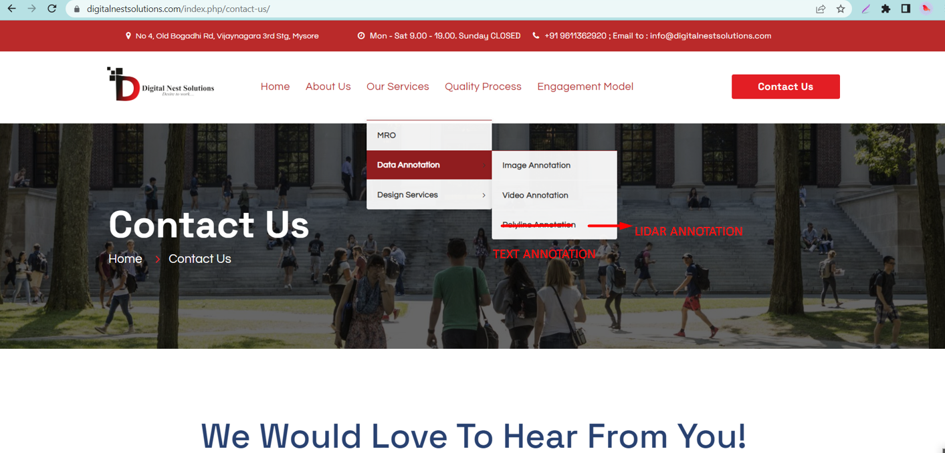

- We need to classify under Annotations
Find the classification below
1. Image annotation
a. Image classification
b. semantic segmentation
c. instance segmentation
d. Object detection
e. Polyline annotation
f. Key point annotation
g. Landmark annotation
2. Video Annotation
3. Lidar Annotation
a. 3D Cuboids Annotation
b. 3D Semantic Annotation
4. Text Annotation
( Refer the attached image below )
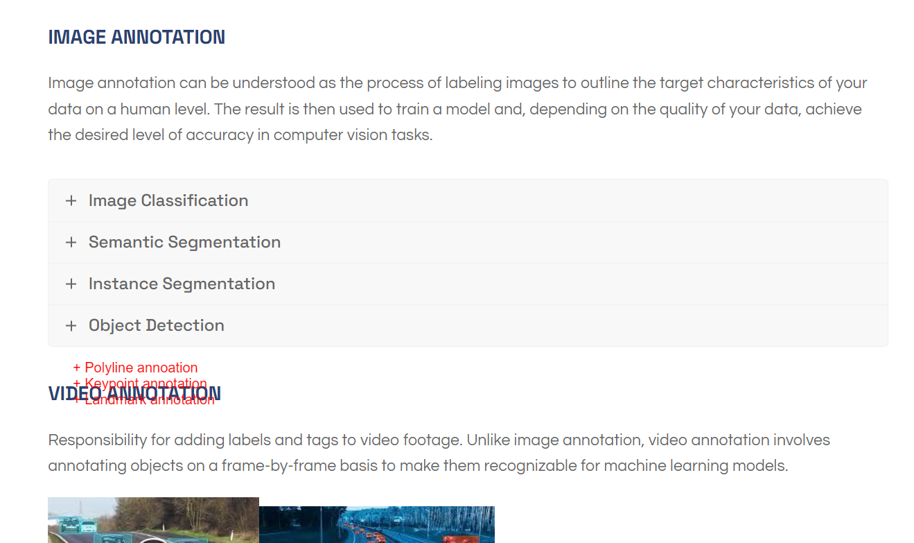

- Related Theme should come to the interface after selecting the topic
(Below image is coming for every topic we select)
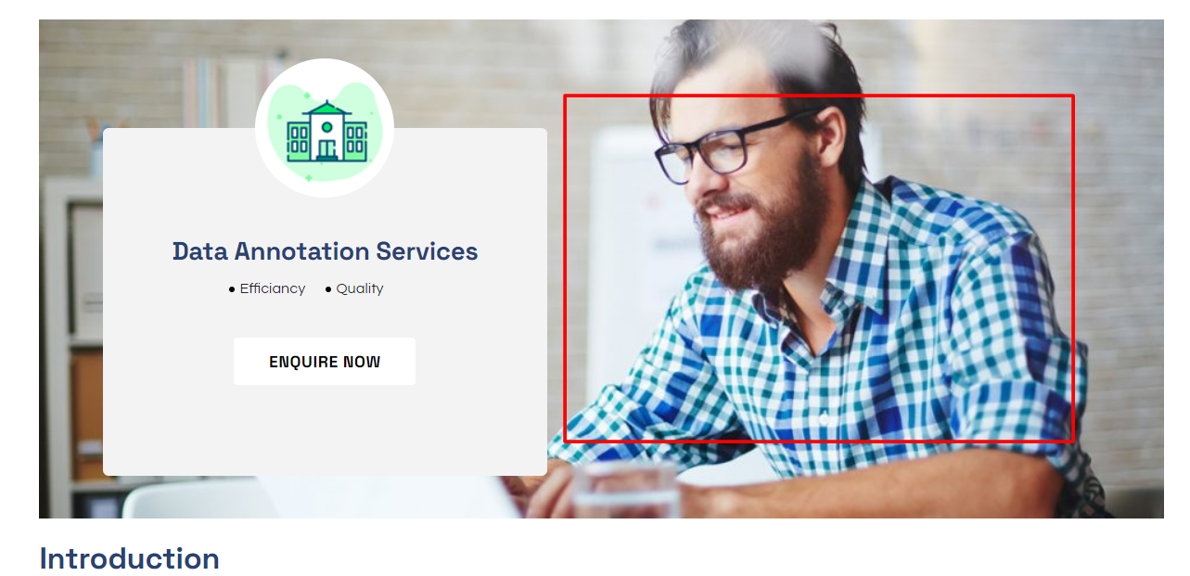

- Data annotation, PV design, Interior design are showing under MRO
They should not come under MRO
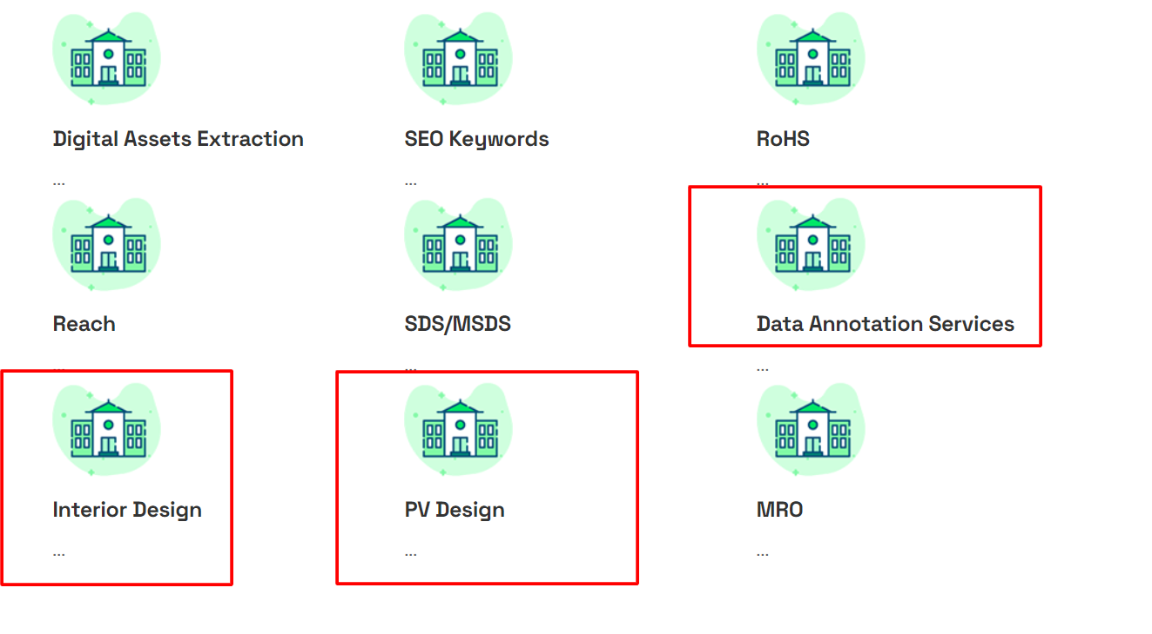
- We need to add a G- Meet Link in schedule an appointment
That should be remain as Schedule an appointment
under that we need to add a G - meet link
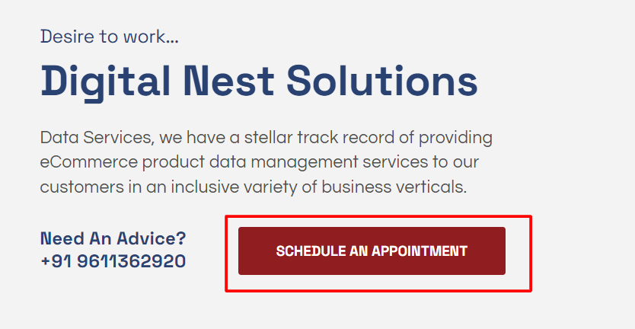

- We should add in Home page about our achievements and expertise
as shown in image
Below example should be added to each services
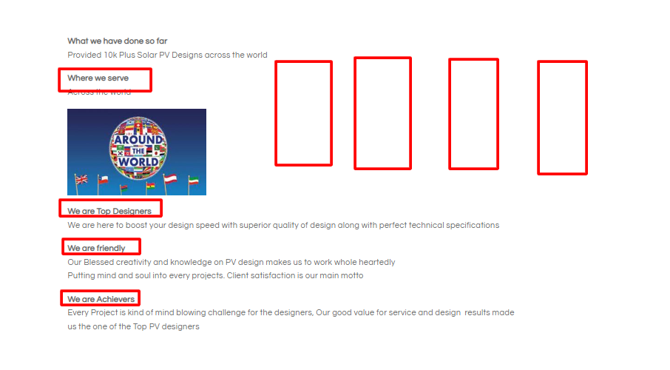

- Need to remove Spectrum of services in home page


- If we click on the Explore under data annotation and Design services
Its not taking us anywhere, it should take us to respective content
